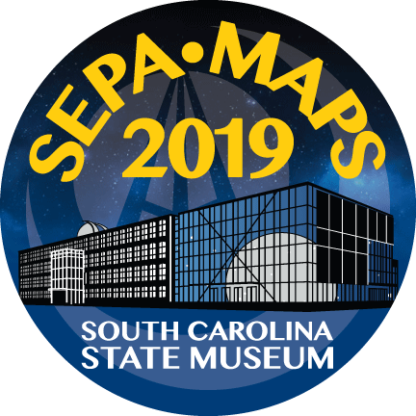

SPONSOR Conference Registration

Please provide the following information for your organization. This registration packet includes an Individual Preferences Form, to be filled out by each attending member. A similar form is provided for guests. These forms enable the individual selection of meals and specification of any special needs.

Organization: ___________________________________________________________

Primary Contact and Representative for this Organization

First Name: ____________________________ Last Name: _________________________

Title: _______________________________________________________

Address: __________________________________________________________________

City: ___________________ State: _______________ Zip: ____________

E-Mail: __________________________________________________________

Phone: ____________________________
Cell phone (for contact during conference): _________________________

Is this your organization’s first SEPA conference (circle one)? YES NO

Is this your organization’s first planetarium conference (circle one)? YES NO

SECTION A: SPONSOR FEES

See the sponsor information document for a full description of the sponsorship levels.

Dome time will be in the BlueCross BlueShield of South Carolina Planetarium, the fully digital permanent 55-foot dome at the South Carolina State Museum.

If you would like to have promotional materials included in the conference bag, there will be a nominal fee of $25 per item type (such as a pen, show catalog, etc...). Please ensure you provide at least 150 units, not later than May 15th, 2019.

If you have chosen the Level 5/SLS sponsorship, please circle which of the following extra benefits you would like to have:

1 additional registration | 15 min of additional dome time | 1 additional 8x8 block in the vendor hall

Sponsorship | Fee |  | Quantity | Amount
Sponsorship Level | 1: Redstone | $250 |  | $
 | 2: Atlas | $500
 | 3: Saturn IB | $1,250
 | 4: Saturn V | $2,500
 | 5: SLS | $3,500
Additional Booth Space in Vendor Hall | $250 per 8x8 ft section |  |  | $
Additional Dome Time (Must be Level 3 or above) | $250/15 min increment |  |  | $
Show Dome Time Block | $100/30 min |  |  | $
Conference Bag Promotional Item | $25/item type |  |  | $
Section A Subtotal |  |  |  | $
SECTION B: SPONSOR REGISTRATION

If there are free registrations included in your sponsorship level, please provide the names of those registrants below (include yourself). Note that each individual registering as part of your organization, whether included in the chosen sponsorship level or not, will need to fill out the Individual Preferences Form found near the end of this packet.

 | First Name | Last Name
1
2
3

If you would like to register additional persons, list their names below. Each additional registrant will be subject to the full conference registration fee.

Additional Sponsor Registrations: FULL Registration

 | First Name | Last Name | Full Registration  ($150 before May 15th/$175 after)
1 |  |  | $
2 |  |  | $
3 |  |  | $
 | Full Registration Total |  | $

Additional Sponsor Registrations: DAILY Registration

 | First Name | Last Name | Number  Of Days | $80/day | Daily Registration
1 |  |  |  | x $80 | $
2 |  |  |  | x $80 | $
3 |  |  |  | x $80 | $
 | Daily Registration Total |  |  |  | $

There is an additional fee for some conference-related activities. Fill out the following if anyone from your organization will be participating in the following:

Conference and Related Activities

 | Activity | Number  Attending | Cost/ Person | Total
1 | Mini-LIPS Workshop |  | x $50 | $
2 | Banquet |  | x $50 | $
3 | Post-Conference Music Performance |  | N/A | N/A
 | Add-ons Total |  |  | $

Section B Subtotal | $

SECTION C: GUESTS of SPONSORS

Meals are included in full and daily registration fees. Guests of registered sponsors who wish to attend a meal may do so with a charge to cover associated costs. Guests will need to fill out a short Guest Preferences Form in order to make meal selections and note any dietary restrictions or special needs.

Date | Meal | Number of Guests | Fee | Total
Tuesday, June 4th | Opening Reception |  | x $25 | $
Wednesday, June 5th | Lunch |  | x $30 | $
Wednesday, June 5th | Dinner |  | x $35 | $
Thursday, June 6th | Lunch |  | x $30 | $
Thursday, June 6th | Dinner |  | x $35 | $
Friday, June 7th | Lunch |  | x $30 | $
Friday, June 7th | Dinner (Banquet) |  | x $50 | $
Saturday, June 8th | Farewell Breakfast |  | x $25 | $
Total Guest Meals |  |  |  | $

SECTION D: TOTALS

Fill in the subtotals from each preceding section and calculate the grand total for your organization.

Section A Subtotal | Sponsorship Levels | $
Section B Subtotal | Registrations | $
Section C Subtotal | Guest Meals | $
GRAND TOTAL |  | $

Mail your check payable to SEPA with completed registration form to:

Patsy Wilson, SEPA Treasurer
140 Lyn Road
Salisbury, NC 28147

Thank you for your generous support of this conference! If you have any questions or issues, please contact the conference host:

Liz Klimek, Planetarium Manager
South Carolina State Museum
liz.klimek@scmuseum.org | 803-898-4985

EXHIBIT HALL PREFERENCES

Using the diagram below, please indicate your top three preferred blocks of space. Each block is 8x8 feet. Each circle is 16 feet in diameter.

1st Choice | Space #__________
2nd Choice | Space #__________
3rd Choice | Space #__________

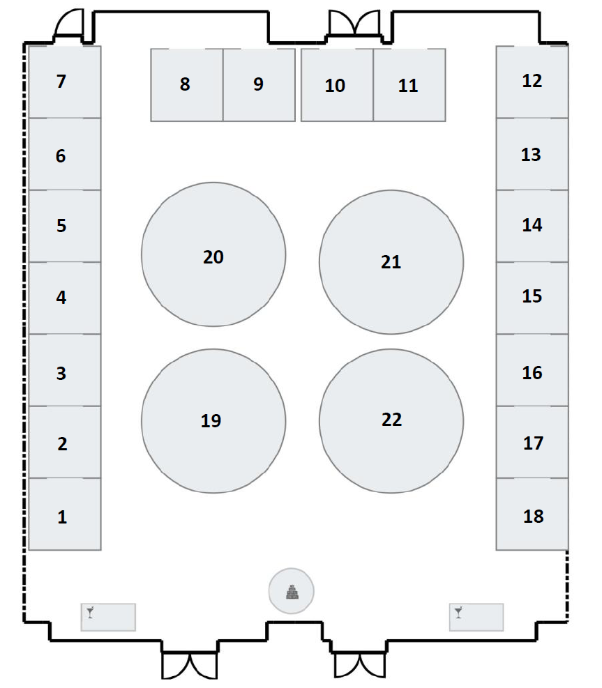
Hall Entrance
INDIVIDUAL PREFERENCES FORM for SPONSORS

Each individual registering as part of your organization will need to fill out and submit the following form. This ensures that we have basic contact info for all registrants and provides a way for every individual to select meal options and list any special considerations.

Sponsoring Organization: ___________________________________________________________

First Name: ____________________________ Last Name: _________________________

Title: ______________________________________________________

E-Mail: ______________________________________________________

Phone: ______________________________________________________

Will you have your own vehicle during the conference? | YES | NO
If so, would you be willing to assist with rides if necessary? | YES | NO
Will you be attending the opening reception? | YES | NO
Are you interested in attending the post-conference music performance? | YES | NO

If you will be attending the dinner banquet, please circle your main entree choice and list any special dietary needs or restrictions.

Beef Salmon Vegetarian

Dietary Restrictions:

Do you have any other special needs or require any special accommodations? If so, please describe.

If you have any questions or concerns about such needs, please contact Liz Klimek at liz.klimek@scmuseum.org or 803-898-4985
GUEST PREFERENCES FORM

If you will be attending meals as a guest, please fill out this form so that we know your meal preferences and can try to accommodate any special needs you may have.

First Name: ____________________________ Last Name: _________________________

Who will you be a guest of?
First Name: ____________________________ Last Name: _________________________

Will you be attending the opening reception? | YES | NO
Are you interested in attending the post-conference music performance? | YES | NO

If you will be attending the dinner banquet, please circle your main entree choice.

Beef Salmon Vegetarian

List or describe and dietary needs or restrictions:

Do you have any other special needs or require any special accommodations? If so, please describe.

If you have any questions or concerns about such needs, please contact Liz Klimek at liz.klimek@scmuseum.org or 803-898-4985.

